Limbo Screen
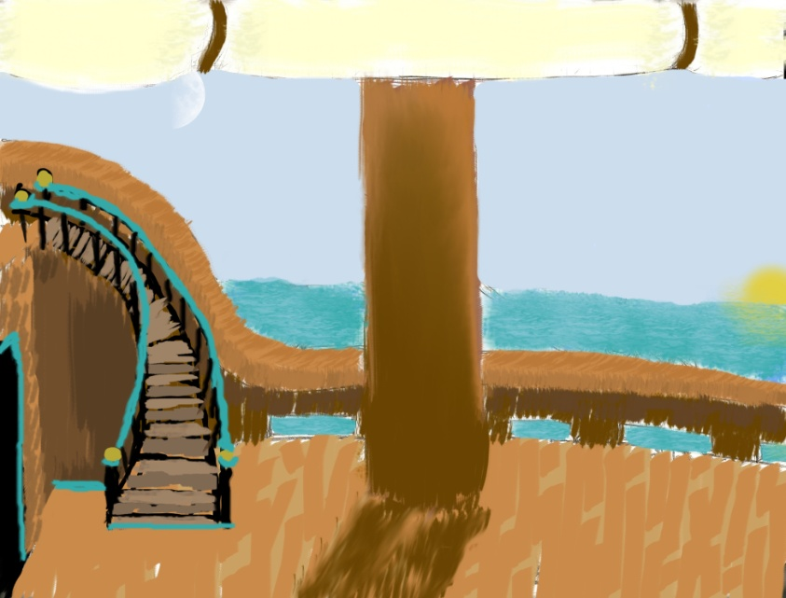
Ivan, Farthing, Checkers, Michael, and a logbook (not pictured) are positioned about the screen. Clicking on any of the characters brings up dialogue. Clicking logbook brings up save/load.

Save Load
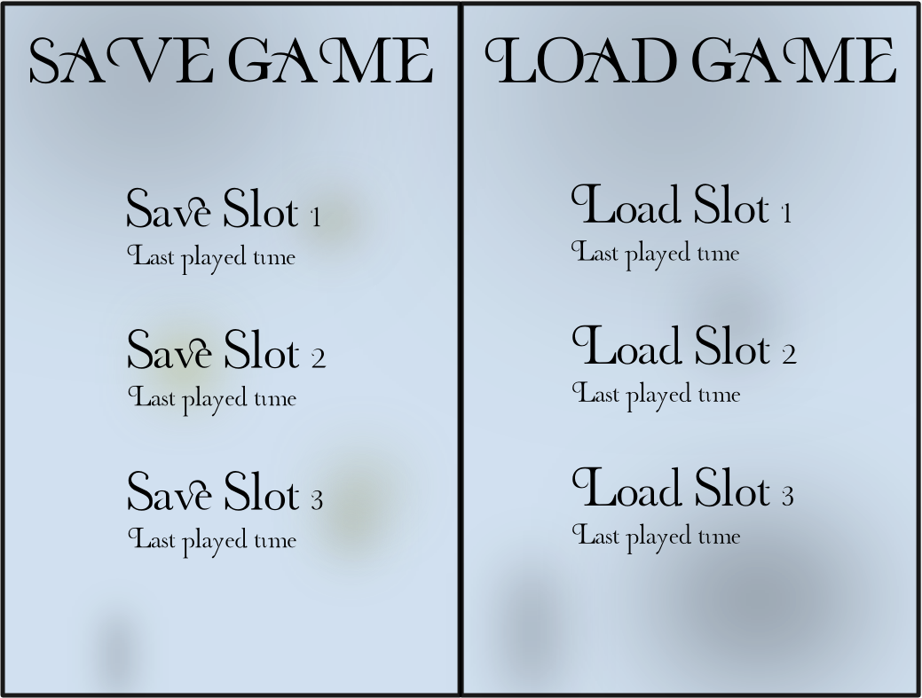
Here, the player selects either a save or a load slot to either save or load. Afterward, the player is brought back to limbo.

Dialogue
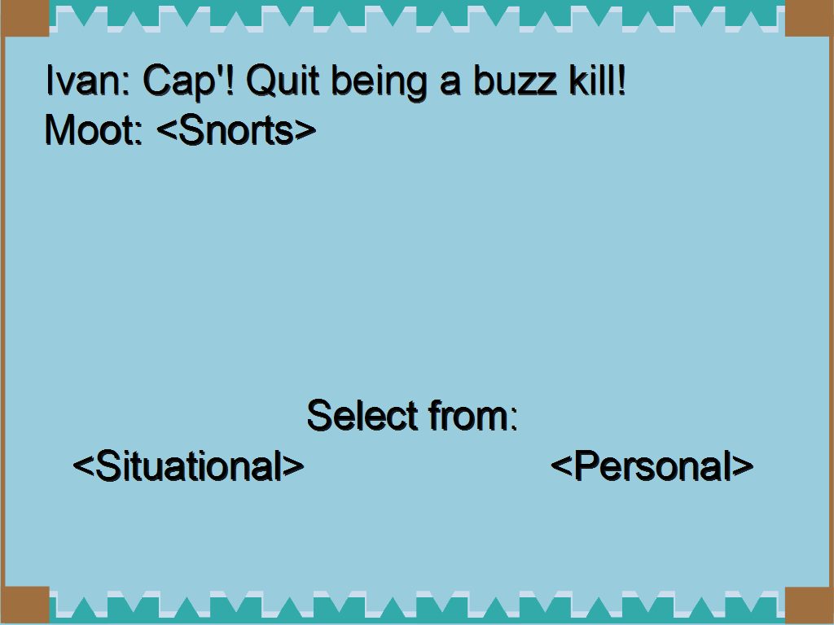
After clicking a character, the camera zooms into him and this screen pops up. If there is a choice needed from the player, the options will be at the bottom (in this case, the options are Situational and Personal).
This box is also shown during missions when a crew member speaks, and at the very beginning of a mission so the player can select a special ability.

Combat Screen
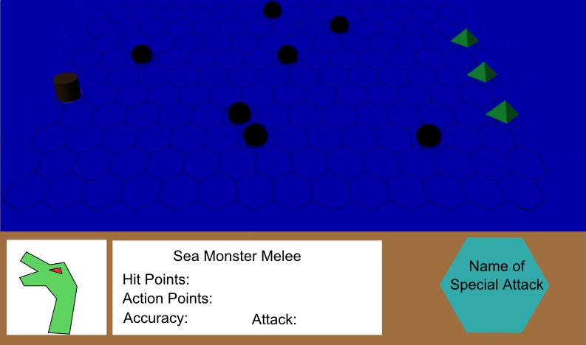
This is a rough example of what the player might see during combat. The HUD at the bottom (the brown box) will show up when a unit is clicked, enemy or otherwise. When no unit is selected, the HUD is not shown. The leftmost element of the HUD is a picture of the selected unit. The middle element gives info on the unit. The rightmost element activates the player’s special ability when clicked.

